Activity 1 – Part 1

Ryan Coon

CST-350

Professor Donna Jackson

May 7, 2023

Screenshot showing the app state after editing the Privacy view.

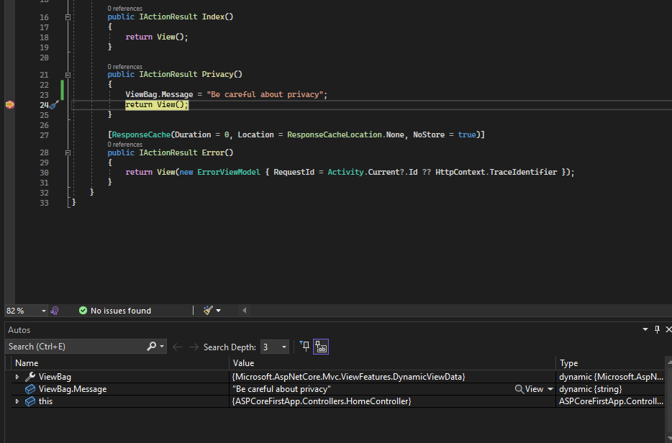

Added the ViewBag.Message and added a breakpoint. Started the application and clicked the privacy button. The breakpoint doesn’t allow the view to continue but we can see what was expected in the console.